

College of Engineering and Computer Science

***ECS 511 – Sustainable Manufacturing***

***Assignment – 3***

***Life Cycle Assessment (LCA)***

***Submitted by:***

***Rishi Siddanth Yaga***

***627161225***

[***riyaga@syr.edu***](mailto:riyaga@syr.edu)

**TABLE OF CONTENTS**

**Summary Statement………………………………………………….03**

**Context of Use of LCA in Quantifying Environmental Impact…....04**

**LCA Setup.............................................................................................06**

**System Boundary……………….................................................07**

**Functional Unit….…………………………….….…………….09**

**Scenarios.......................................................................................10**

**Data Sources…………………….….…………………………...11**

**LCA Calculations………………….….………………………………13**

**How LCA is Calculated…………………………...……………13**

**Carbon Footprint Calculations………...………………………14**

**Eco Cost Calculations………...………………...………………17**

**Results………………...…………………………………………20**

**Conclusion…………………….............................................................21**

**Bibliography..........................................................................................24**

**Appendix…............................................................................................26**

**SUMMARY STATEMENT**

The Life Cycle Assessment (LCA) of an LED Desk Lamp encompasses a comprehensive system boundary, covering all stages from raw material extraction to disposal. This includes the environmental impacts associated with material extraction, manufacturing, transportation, usage, and end-of-life management. The functional unit of the LCA is defined as the illumination of a standard-sized desk for one year, providing a consistent basis for comparison. The analysis compares LED lamps with traditional incandescent lamps, focusing on energy consumption and greenhouse gas emissions. The outcomes demonstrate that LED lamps significantly reduce environmental impacts, including energy use and emissions, making them a more sustainable choice over traditional lighting options. This LCA highlights the importance of considering the entire lifecycle in assessing the environmental sustainability of lighting products.

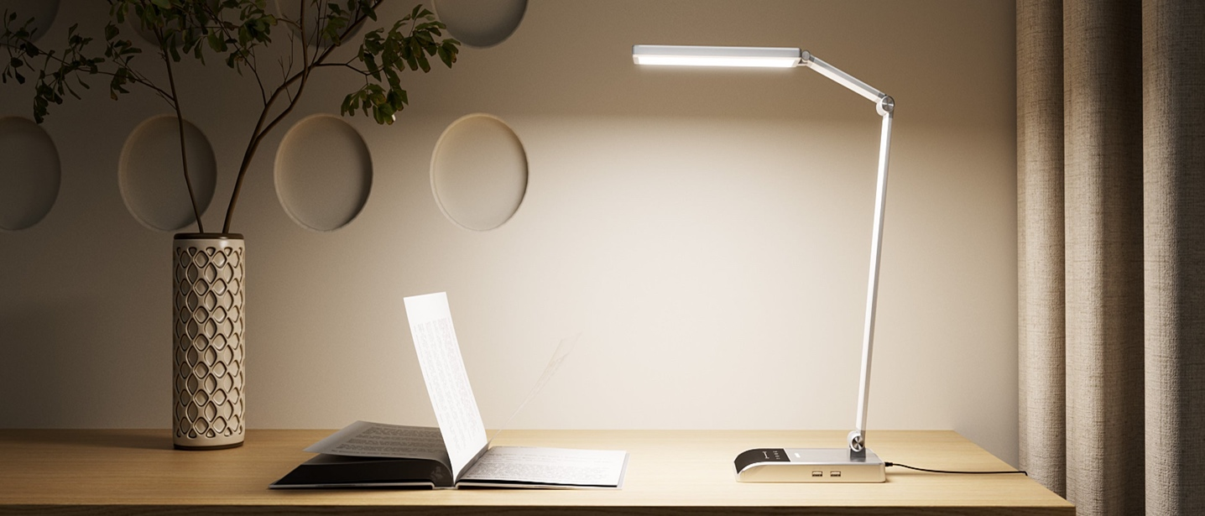

Fig.1

**CONTEXT FOR THE USE OF LCA IN QUANTIFYING ENVIRONMENTAL IMPACT**

Life Cycle Assessment (LCA) is a crucial tool in quantifying the environmental impact of products like LED desk lamps. It provides a holistic view of a product's entire lifecycle, from its creation through its use and eventual disposal. This comprehensive approach allows us to understand the environmental implications associated with various stages of a product's existence, helping us make informed decisions about sustainability and environmental responsibility.

LCA plays a significant role in sustainable product design and decision-making. By assessing the environmental impact of different aspects of a product, such as materials, manufacturing processes, transportation, and energy consumption during its operational phase, LCA enables manufacturers, designers, and consumers to identify areas where improvements can be made to reduce environmental harm. This information is invaluable for making informed choices that align with sustainability goals and regulatory requirements.

In the case of LED desk lamps, LCA helps us compare their environmental performance with traditional lighting options like incandescent bulbs. It considers factors such as the energy efficiency of LEDs, the materials used in their production, the reduction in greenhouse gas emissions due to lower energy consumption, and the potential for recycling or responsible disposal at the end of their lifespan.

Ultimately, LCA empowers us to make more sustainable choices by quantifying the environmental consequences of our decisions, driving innovation in product design and manufacturing processes, and supporting the transition to greener and more eco-friendly technologies like LED desk lamps. It not only benefits businesses by enhancing their environmental credentials but also contributes to a healthier planet by reducing the overall environmental footprint of the products we use in our daily lives.

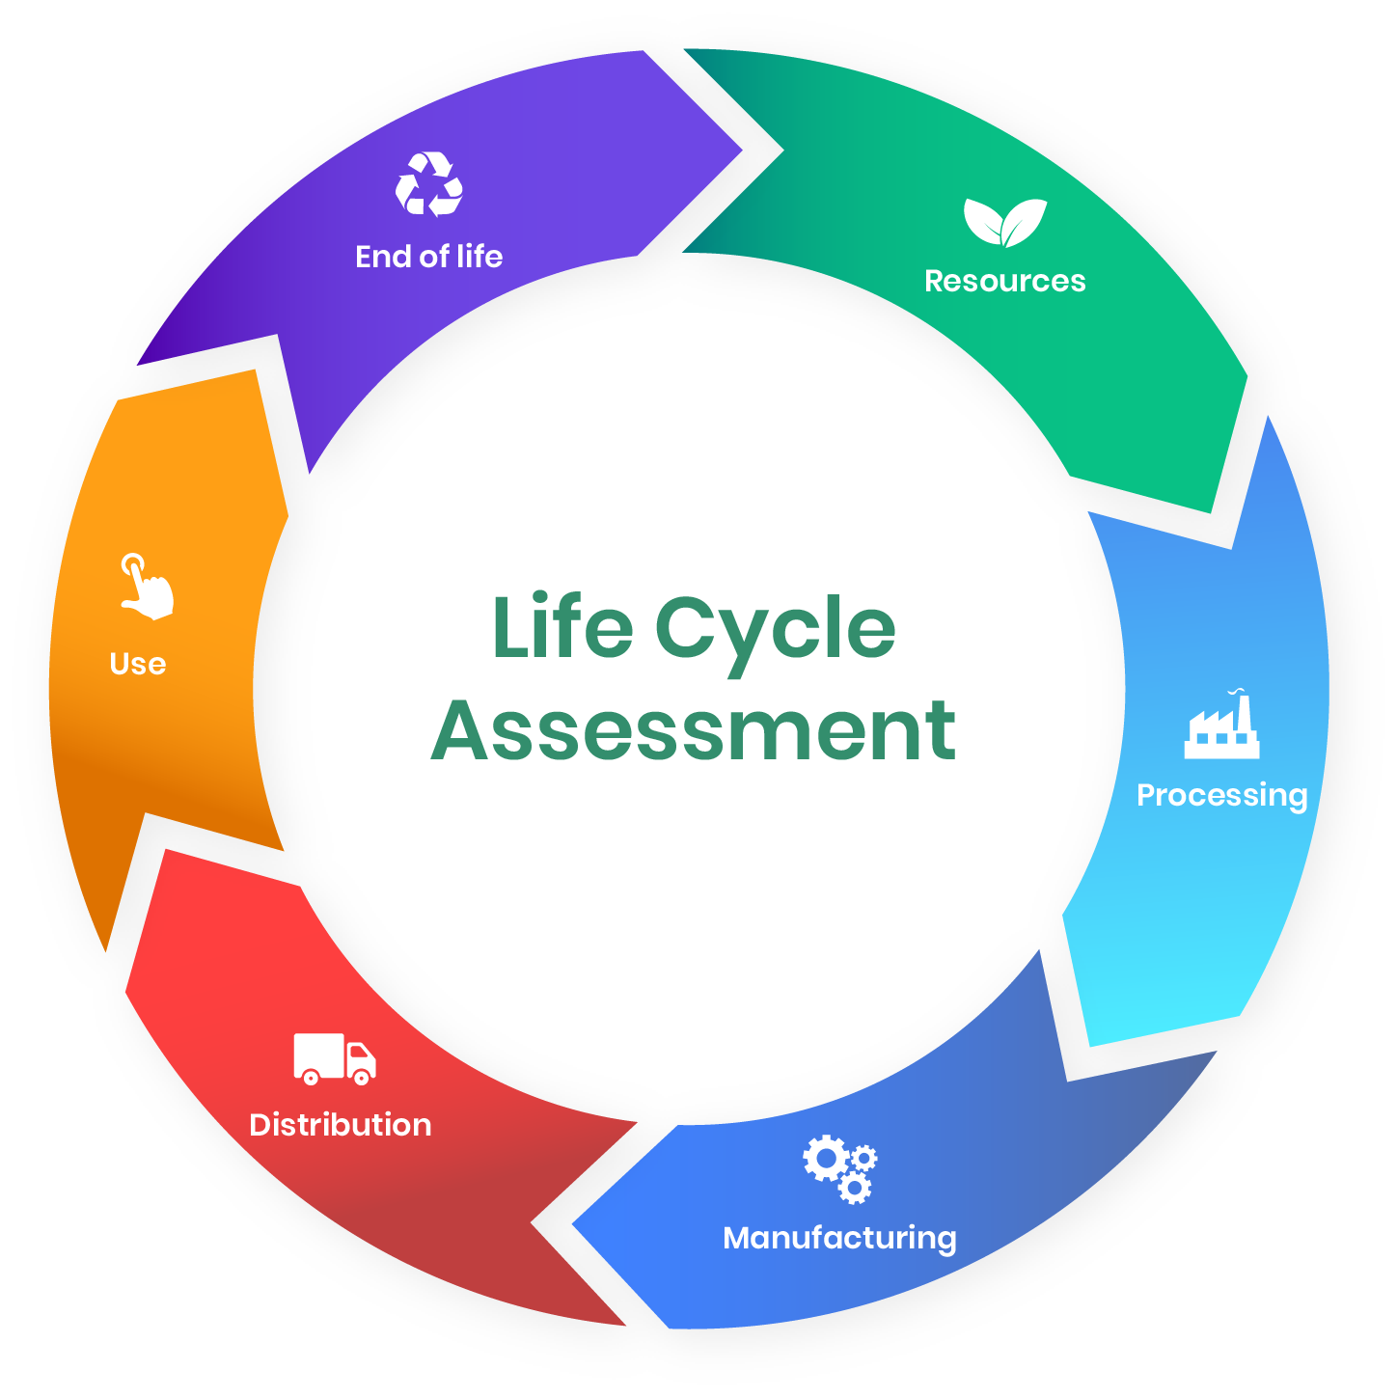

Fig.2

**LCA SETUP**

Life Cycle Assessment (LCA) is an analytical tool used to comprehensively evaluate the environmental impacts of a product, process, or service throughout its entire life cycle. This assessment encompasses every stage, from raw material extraction (such as mining and logging), through production and manufacturing, distribution, and use, to disposal or recycling. By quantifying factors like energy use, resource depletion, emissions to air and water, and waste generation, LCA provides a holistic view of the environmental footprint. It enables businesses and policymakers to make informed decisions that prioritize sustainability and helps identify opportunities for reducing environmental impacts at different stages of the life cycle. LCA is integral in promoting sustainable development, supporting eco-design of products, and guiding consumers towards more environmentally friendly choices.

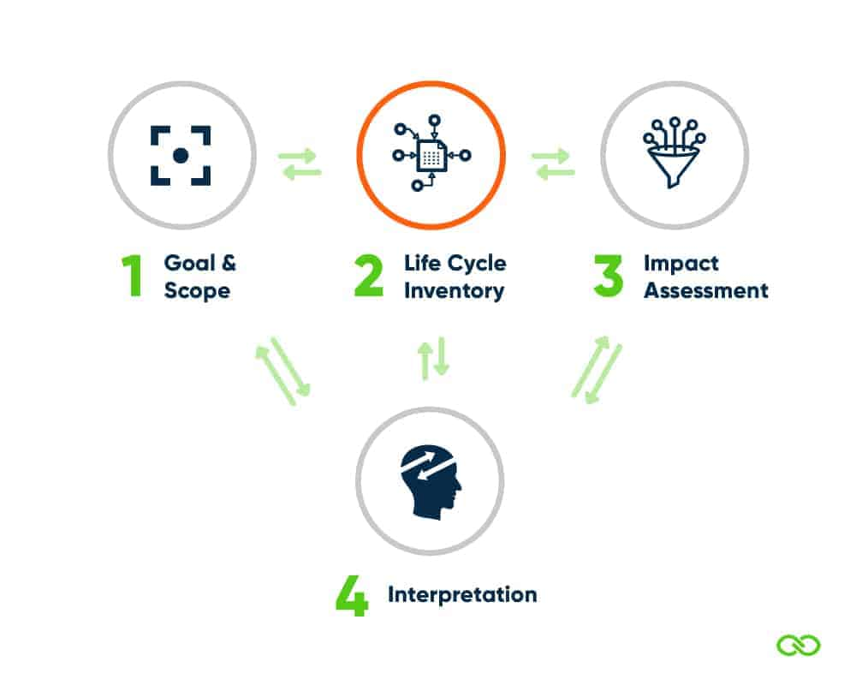

Fig.3

**SYSTEM BOUNDARY**

For the Life Cycle Assessment (LCA) of the LED Desk Lamp, the system boundary encompasses the entire lifecycle of the product, from cradle to grave. This includes the following stages:

Raw Material Extraction and Processing: This stage involves extracting and processing materials like metals, plastics, and electronic components needed for the lamp. It is marked by environmental impacts due to energy consumption and emissions from mining and refining processes.

Lamp Manufacturing: During this phase, extracted materials are transformed into the final product, involving assembly, testing, and packaging. It includes the energy used in manufacturing processes and the waste generated, along with potential pollution from factory operations.

Transportation of Materials and Finished Products: This stage covers the movement of raw materials to manufacturing sites and the distribution of the finished lamps to retailers or consumers. It involves the fuel consumption and greenhouse gas emissions associated with transportation vehicles.

Operational Phase (Energy Consumption during Use): This crucial phase involves the energy consumption of the lamp during its operational life. The focus is on electricity usage for providing illumination and the corresponding emissions from power generation, especially relevant for comparing different types of lamps.

End-of-Life Scenarios (Recycling, Disposal, or Landfill): This final stage deals with the disposal or recycling of the lamp after its useful life. It encompasses waste management practices, the potential release of hazardous substances, and the environmental impact of recycling processes or landfilling.

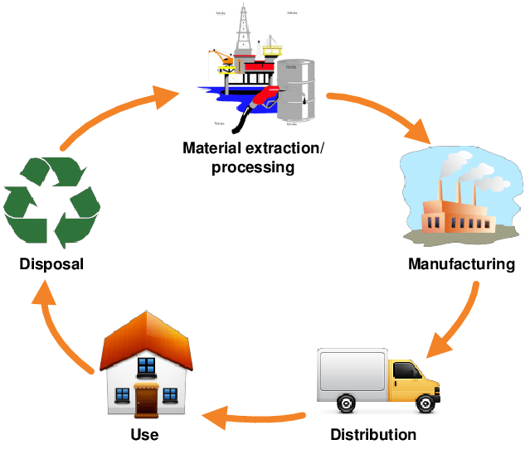

Fig.4

**FUNCTIONAL UNIT**

In the Life Cycle Assessment (LCA) of the LED Desk Lamp, the "functional unit" is a crucial concept that defines the basis for comparison and analysis. For this specific LCA, the functional unit is set as the illumination of a standard-sized desk for one year. This choice is significant because it establishes a clear, quantifiable, and comparable measure for assessing the environmental impact of different lighting technologies. By focusing on the amount of light provided over a consistent time, it allows for an objective evaluation of the efficiency and environmental performance of LED desk lamps in comparison to traditional lighting options. This approach ensures that the analysis is centered not just on the product itself, but on the service, it provides lighting, thereby facilitating a more meaningful and relevant comparison of its lifecycle impacts.

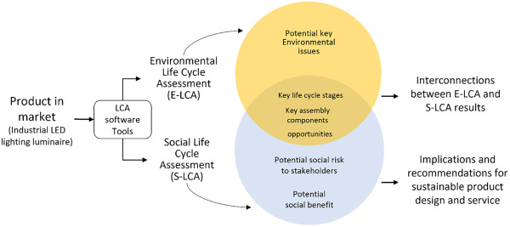

Fig.5

**SCENARIOS**

LED Desk Lamp (Baseline Scenario): This scenario evaluates the environmental impacts of using an LED desk lamp as the primary light source for a desk over one year. It establishes a reference point for comparison, focusing on the energy consumption, material use, and emissions associated with the standard LED lamp technology.

Incandescent Desk Lamp Scenario: Here, the environmental impacts of using a traditional incandescent desk lamp for the same duration and lighting purpose are analyzed. This scenario allows for a direct assessment of how LED lamps compare to older, less efficient incandescent lamps in terms of energy use and associated environmental footprint.

Energy-Efficiency Upgrade Scenario: This scenario investigates the environmental benefits of an LED desk lamp equipped with advanced features like dimming and occupancy sensors, which further enhance energy efficiency. It emphasizes the role of innovative design in reducing environmental impact, highlighting how additional energy-saving features can lead to even greater sustainability gains.

**DATA SOURCES**

Product Specifications and Materials Data (Manufacturer): This includes detailed information on the materials, components, and construction of the LED desk lamp, provided directly by the manufacturer, ensuring specific and accurate data for the product in question.

Eco invent Database for Materials Extraction and Manufacturing: A comprehensive database offering data on the environmental impacts of raw material extraction and manufacturing processes, essential for assessing the upstream impacts of the lamp’s components.

National or Regional Energy Consumption Statistics: These statistics provide information on the average energy consumption and energy mix in the location where the lamp is used, crucial for accurately assessing the operational energy footprint of the lamp.

Transportation and Logistics Databases: These databases offer insights into the environmental impacts of transporting materials and finished products, including data on transport distances, modes, and fuel types, which are vital for evaluating the transportation phase.

End-of-Life Data from Waste Management and Recycling Facilities: This data covers recycling rates, methods of disposal, and the environmental impact of waste management processes, essential for a thorough assessment of the lamp’s end-of-life stage.

The chosen data sources have been selected based on their reliability, relevance to the system boundary, and alignment with the ISO 14040 and 14044 standards for LCA. By using these data sources, the LCA ensures a robust and credible analysis of the environmental impact of the LED desk lamp throughout its lifecycle.

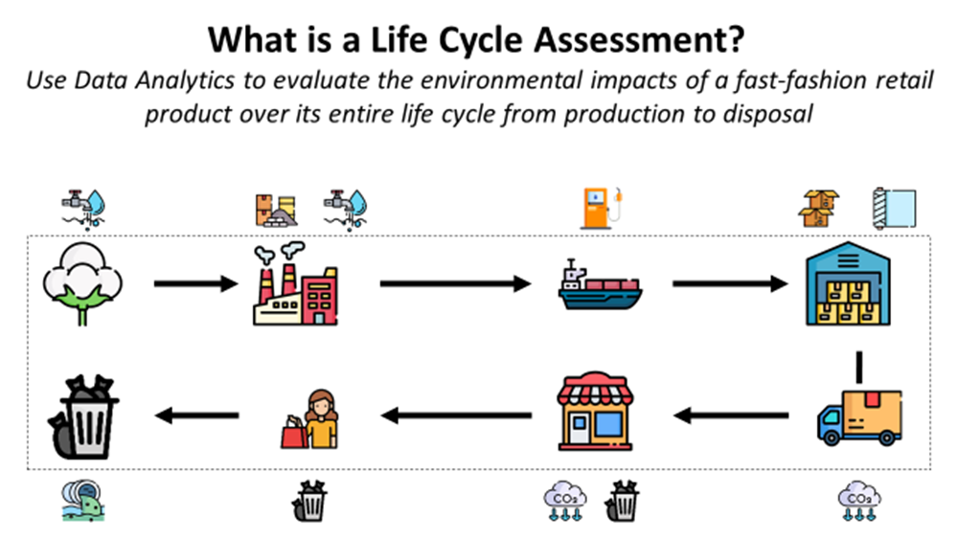

Fig.6

**LCA CALCULATIONS**

How LCA is Calculated?

The Life Cycle Assessment (LCA) for an LED Desk Lamp, as outlined in the LCA Calculator Excel file, involves a systematic process utilizing various sheets each dedicated to different aspects of the LCA. The "Carbon Footprint" sheet includes formulas and data for estimating greenhouse gas emissions throughout the lamp's lifecycle, encompassing stages like material extraction, manufacturing, and usage. The "Eco-Cost" sheet appears to calculate the environmental impact cost, integrating factors like resource depletion and pollution. The "Eco invent V3.3+Idemat" sheet presumably provides detailed environmental impact data for materials and manufacturing processes, sourced from a comprehensive database. The LCA calculation would involve inputting data such as material types, energy use, and transportation details into these sheets. This data is then processed through embedded formulas or models to quantify the environmental impacts in different categories, allowing for a comprehensive environmental performance evaluation of the LED Desk Lamp across its lifecycle. This methodology ensures a robust and thorough assessment, aligning with standards like ISO 14040 and 14044 for LCA.

**Carbon Footprints Calculations:**

Fig.7

Fig.8

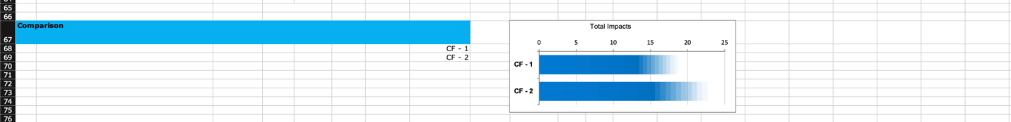

Fig.9

* Manufacturing: For both CF - 1 and CF - 2, ABS Plastic has the highest calculated impact in manufacturing, due to its eco-intensity and mass per item. However, CF - 1 includes Steel and LED, which are not present in CF - 2. CF - 2, on the other hand, includes Rubber, which is not listed in CF - 1.
* Transport: Both design options have transportation impacts due to road travel, but CF - 1 has a larger mass per item to transport, leading to a higher calculated impact despite a shorter distance (2500 km for CF - 1 vs. 4500 km for CF - 2).
* Use: The use phase, quantified by energy consumption (Energy Via Electricity), is consistent in both options, with the same eco-intensity and amount per item. However, the calculated impact is higher for CF - 1, which could be due to a different number of items or different energy consumption profiles.
* End of Life: The end-of-life impacts show a negative calculated impact for Aluminum Waste in both cases, indicating a potential credit for recycling or other beneficial end-of-life processes. The calculated impact for ABS Waste is higher in CF - 1 compared to CF - 2.
* Total Impacts: The comparison chart shows that CF - 1 has a higher total impact than CF - 2, suggesting that CF - 2 is the more environmentally friendly option overall.
* Bar Charts: The bar charts illustrate that the materials and manufacturing stage have the highest impact in both CF - 1 and CF - 2. However, CF - 1 has a notably higher impact in the transport phase than CF - 2. The use phase has a relatively small impact in both cases, and the end-of-life phase has a negative impact, likely due to the recycling potential of materials like aluminum.

In summary, while CF - 1 has a higher impact in manufacturing due to additional components like Steel and LED, it also incurs a higher impact in the transport phase. CF - 2 manages to have a lower overall impact despite the longer transportation distance, which could be due to lower mass per item or more efficient logistics. The use phase is similar for both, but the end-of-life phase shows the environmental benefit of recycling Aluminum. Overall, CF - 2 appears to be the more sustainable design option between the two.

**Eco- Cost Calculations:**

Fig.10

Fig.11

Fig.12

Manufacturing:

EC - 1: Uses ABS Plastic, Copper Wire, Aluminum, Steel, and LED. ABS Plastic has the highest calculated impact, followed by Copper Wire and Aluminum. Steel and LED have the lowest impacts.

EC - 2: Like EC - 1, ABS Plastic has the highest impact, but Copper Wire's impact is slightly higher in EC - 2 compared to EC - 1. Rubber is introduced in EC - 2, which is not present in EC - 1.

Transport:

EC - 1: The transport impact is calculated based on the product being transported via road. It has a lower calculated impact than EC - 2.

EC - 2: Despite the eco-intensity per ton-km being the same as EC - 1, the calculated impact is higher, possibly due to increased uncertainty or distance.

Use:

Both design options have a minimal impact in the use phase, which is based on the energy consumption via electricity.

End of Life:

Both EC - 1 and EC - 2 show significant end-of-life impacts from ABS Waste. EC - 2 has a slightly higher impact from ABS Waste compared to EC - 1. Electronic Waste is also considered in both cases, with negligible impact.

Total Impacts:

The total impacts shown in the comparison chart indicate that EC - 2 has a higher overall impact than EC - 1.

Bar Charts:

The bar charts for both EC - 1 and EC - 2 show that the materials and manufacturing stage have the largest environmental impact. The transport stage also contributes significantly, especially in EC - 2.

In summary, while both design options have similar components, EC - 2's overall environmental impact is higher than EC - 1's. This could be due to a variety of factors including the mass of the items, the distance transported, and the eco-intensity of each component. The transport stage has a notable impact on both options, and it is significantly higher in EC - 2. The use stage is minimal for both options. End-of-life impacts suggest that the disposal and potential recycling of ABS present significant considerations.

Overall, EC - 1 appears to be more environmentally friendly than EC - 2 based on the total impacts. However, specific strategies to mitigate the high-impact areas in materials and manufacturing and transportation would be beneficial for improving the environmental profile of both design options.

**RESULTS**

CF-1 vs. CF-2: CF-2 is more environmentally friendly than CF-1, with lower impacts in most categories except for transport.

EC-1 vs. EC-2: EC-1 is more environmentally friendly than EC-2, mainly due to lower impacts in manufacturing and transport.

LCA Detailed Analysis:

When comparing CF-1/EC-1 with CF-2/EC-2, the key factors contributing to the environmental impacts are the materials used in manufacturing and the transport phase. The use phase seems to have a consistent, minimal impact across all options, indicating that operational energy use is not a significant differentiator in this assessment.

For manufacturing, the choice and quantity of materials such as ABS Plastic, which has a high eco-intensity, drive the environmental impact. In the transport phase, the mass of the items and the distance traveled significantly affect the impact, with higher mass and longer distances increasing the footprint.

The end-of-life analysis reveals that proper disposal or recycling, especially of ABS, could provide environmental benefits, as seen from the negative impacts associated with Aluminum Waste, suggesting credits for recycling processes.

In both CF and EC comparisons, the design options with lower total impacts (CF-2 and EC-1) may be considered better from an environmental standpoint, assuming that all other factors like functionality and cost are equal.

**CONCLUSION**

The LCA of the LED Desk Lamp suggests prioritizing the use of sustainable materials, optimizing transportation, and enhancing end-of-life recycling. These strategies are essential for reducing the environmental impact and aligning with sustainable manufacturing practices. Adopting these measures will significantly contribute to the product's overall sustainability and ecological responsibility.

Recommendations Based on LCA Findings:

Material Selection:

opt for materials with lower eco-intensity such as recycled ABS Plastic or alternative bioplastics to reduce manufacturing impact.

Evaluate the possibility of using less Copper Wire or finding an alternative with lower environmental impact.

Consider the end-of-life phase in the design process, promoting recyclable materials to enhance the product's sustainability.

Transport Optimization:

Implement more efficient logistics strategies, possibly by reducing the transport distance or optimizing load management.

Consider local sourcing of materials to minimize the carbon footprint associated with transportation.

Energy Efficiency During Use:

Even though the impact is minimal, improving the energy efficiency of the LED Desk Lamp could still contribute to a lower use-phase impact.

Promote energy-saving features, such as dimming capabilities or automatic shut-off, to reduce electricity consumption.

End-of-Life Management:

Design the lamp to be easily disassembled for better recycling options.

Establish a take-back or recycling program to manage the end-of-life phase responsibly.

Continuous Improvement:

Regularly update the LCA to reflect technological advances and changes in manufacturing processes.

Engage in continuous monitoring of the product’s life cycle to identify new opportunities for impact reduction.

Implications for Sustainable Manufacturing Strategies:

The LCA findings for the LED Desk Lamp underscore the importance of integrating environmental considerations throughout the product's life cycle. Sustainable manufacturing strategies may include:

Eco-Design: Incorporating LCA results from the outset to minimize environmental impacts during design and development.

Supply Chain Management: Working closely with suppliers to ensure the sourcing of sustainable materials and to optimize the supply chain for environmental efficiency.

Product Stewardship: Taking responsibility for the entire life cycle of the product, including post-consumer stages, to minimize the ecological footprint.

Reflection on the Importance of These Recommendations:

Incorporating these recommendations is crucial for enhancing the sustainability profile of the LED Desk Lamp. By doing so, the product can contribute to a lower environmental impact, which is increasingly valued by consumers and regulators alike. Sustainable practices can lead to cost savings in the long term, improve brand image, and ensure compliance with environmental regulations. Most importantly, these practices demonstrate a commitment to the stewardship of our planet, addressing the urgent need to mitigate the effects of climate change and preserve natural resources. This holistic approach to product sustainability is not only a competitive advantage but also a moral imperative in today's environmentally conscious market.

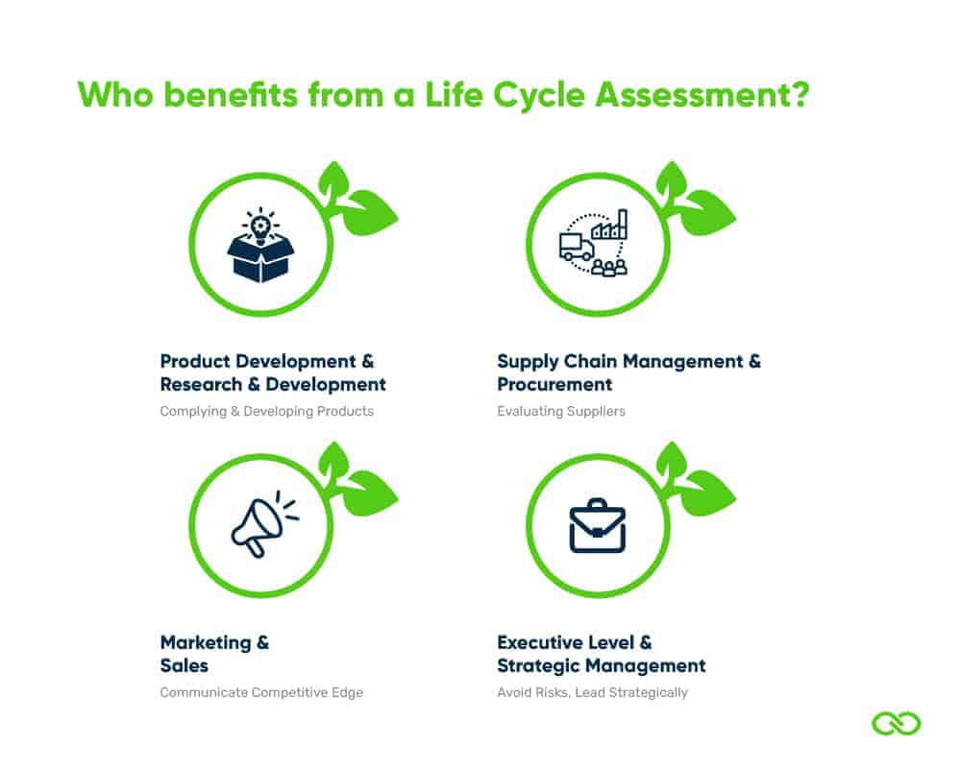

Fig.13

**BIBLIOGRAPHY**

* LePower. (n.d.). Desk Lights. Retrieved from <https://www.lepower-tec.com/collections/desk-light>
* One Click LCA. (n.d.). Life Cycle Assessment Explained. Retrieved from <https://www.oneclicklca.com/se/life-cycle-assessment-explained/>
* Ecochain. (n.d.). Life Cycle Assessment (LCA) Guide. Retrieved from <https://ecochain.com/blog/life-cycle-assessment-lca-guide/>
* Innoveox. (n.d.). Life Cycle Assessment and Sustainability. Retrieved from <https://innoveox.eu/life-cycle-assessment-and-sustainability/>
* Peeters, J. R., Damen, K., Verbruggen, A. V., & Schoenberger, H. (2022). Circular Economy and Life Cycle Assessment: A Review. Resources, Conservation and Recycling, 179, 105976. <https://doi.org/10.1016/j.resconrec.2022.105976>
* Liao, W., Li, X., Huang, G., & Huang, Y. (2022). A Review of Life Cycle Assessment (LCA) and Its Recent Applications in the Construction Industry. Sustainable Production and Consumption. <https://doi.org/10.1016/j.spc.2022.02.005>
* Ecochain. (n.d.). Life Cycle Assessment (LCA) Guide. Retrieved from <https://ecochain.com/blog/life-cycle-assessment-lca-guide/>
* Guinée, J. B., & Heijungs, R. (2014). A Proposal for the Definition of Resource equivalency in Life Cycle Assessment. Journal of Cleaner Production, 80, 122-131. <https://doi.org/10.1016/j.jclepro.2014.05.002>
* Guinée, J. B., & Heijungs, R. (2007). A Proposal for the Definition of Resource equivalency in Life Cycle Assessment. Journal of Cleaner Production, 15(13-14), 1299-1313. <https://doi.org/10.1016/j.jclepro.2006.11.019>
* Wang, L., Wang, X., & Jiang, P. (2022). Comparative Life Cycle Assessment of Solar Photovoltaic Systems: A Case Study in China. Sustainable Energy Technologies and Assessments, 52, 101446. <https://doi.org/10.1016/j.seta.2022.101446>

**APPENDIX**

The Appendix consists of all the LCA Calculations that are used in this report, below mentioned are the screenshots of the same:

Fig.14

Fig.15

Fig.16

Fig.17